CYBERSAFETY
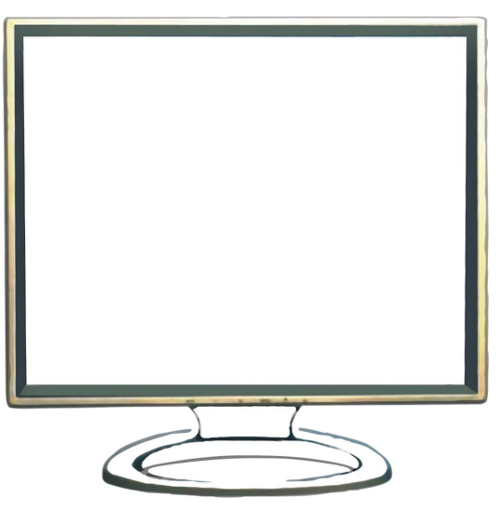
INSIDE THE COMPUTER SCREEN, WRITE DOWN WHAT YOU THINK OF WHEN YOU HEAR THE TERM ‘CYBERSAFETY’. ADD EXAMPLES OF WHAT IT MEANS TO BE ‘CYBERSAFE’
Source: cybersmart (2015)

